# Sandra Yeo: SQL Assignment 1

1. **Do we have actors in the actor table that share the full name and if yes display those shared names.**

Answer: Yes. 2 actors share the same name.

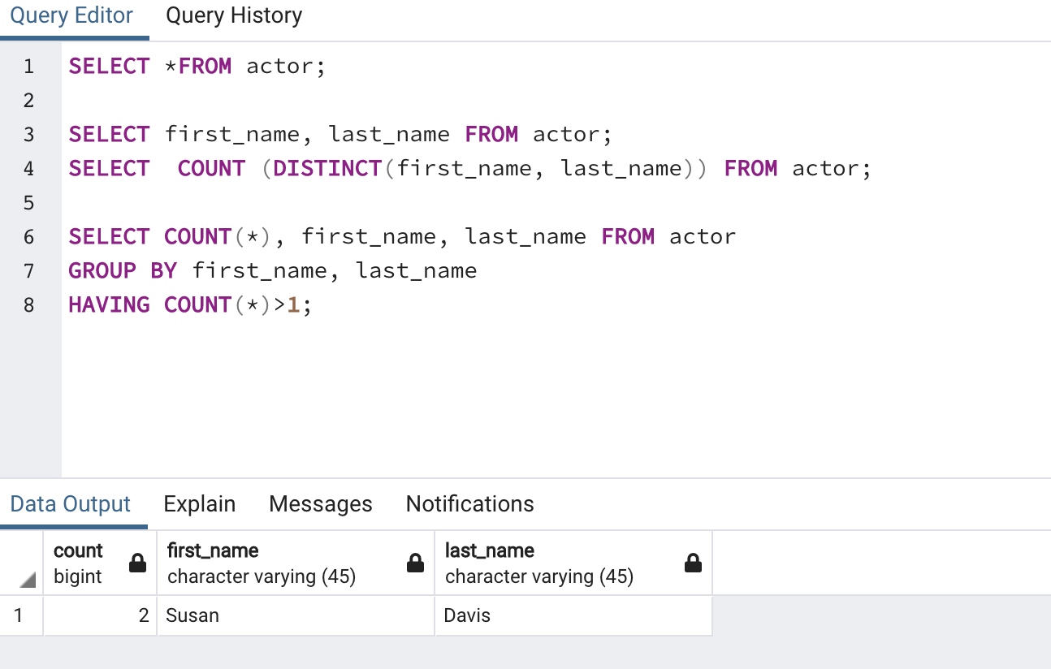

1. **Return the customer IDs of customers who have spent at least $110 with the staff member who has an ID of 2.**

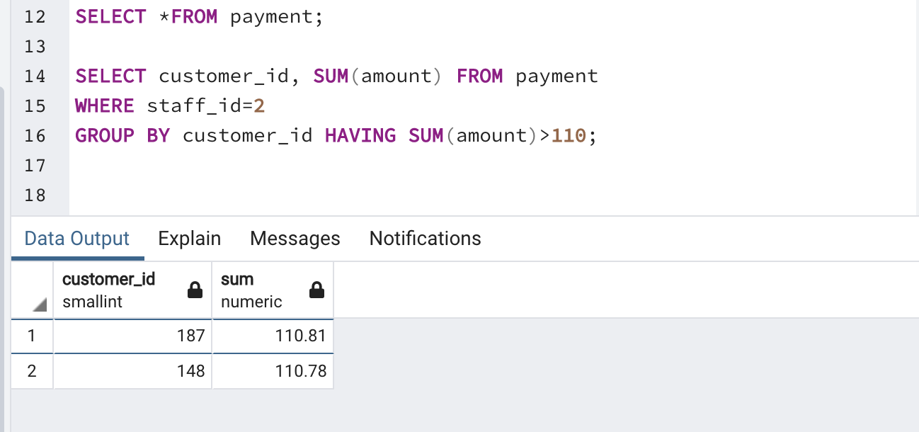

1. **How many films begin with the letter J?**

Answer: 20.

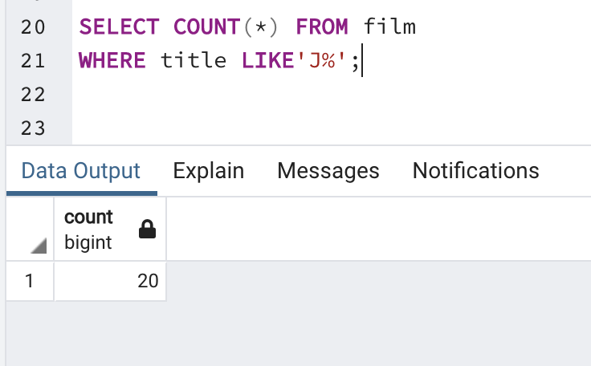

1. **What customer has the highest customer ID number whose name starts with an 'E' and has an address ID lower than 500?**

Answer: Eddie Tomlim.

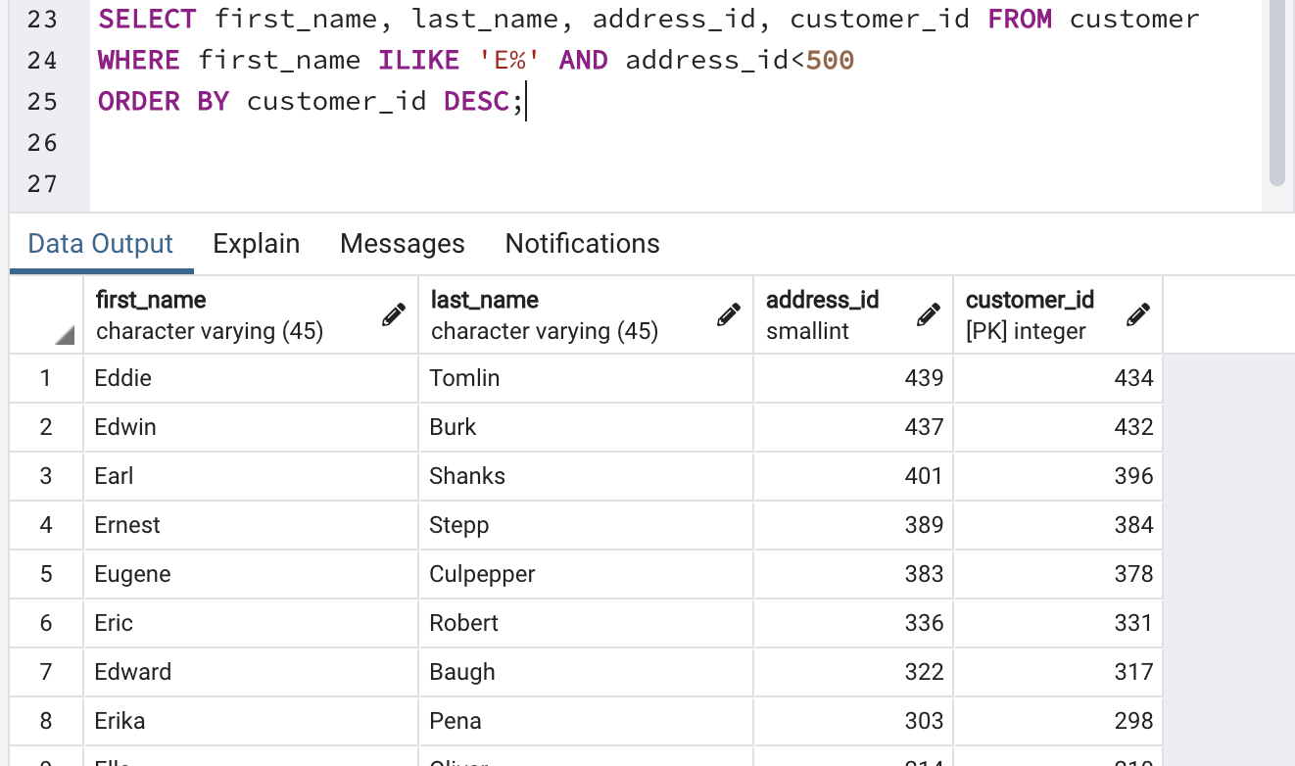

1. **How many films have the word Truman somewhere in the title?**

Answer: 5

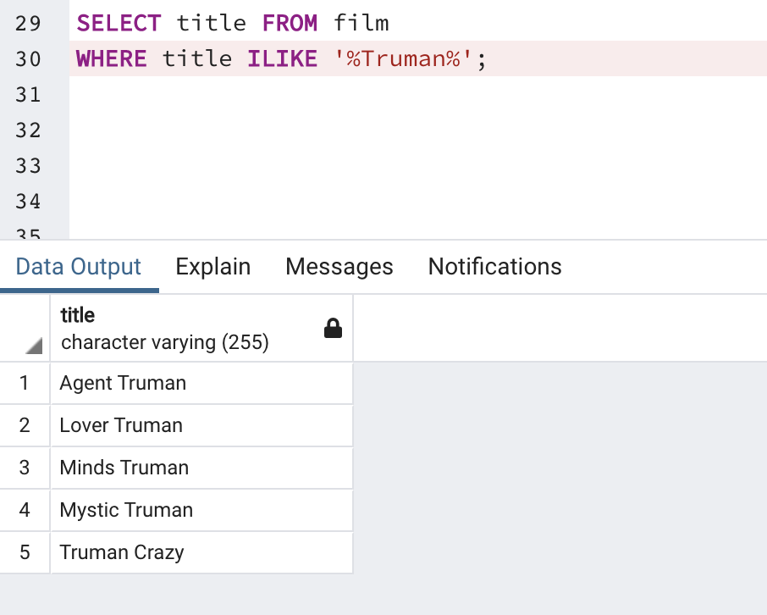

1. **Display the total amount payed by all customers in the payment table.**

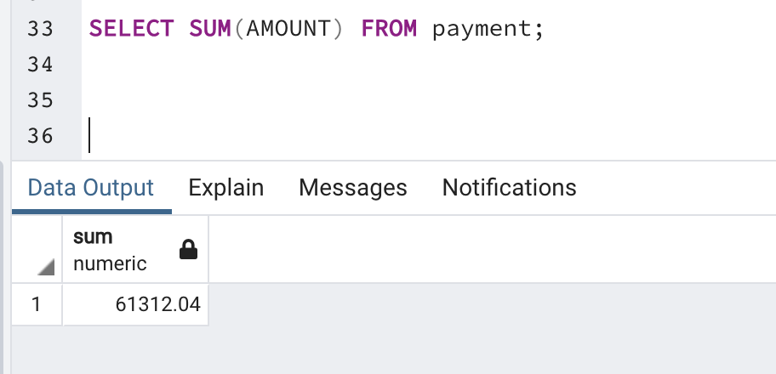

1. **Display the total amount payed by each customer in the payment table.**

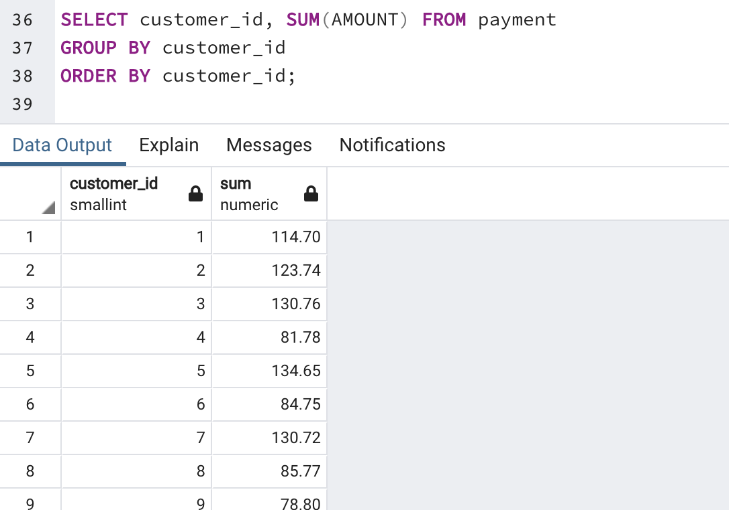

1. **What is the highest total_payment done.**

Answer: $211.55

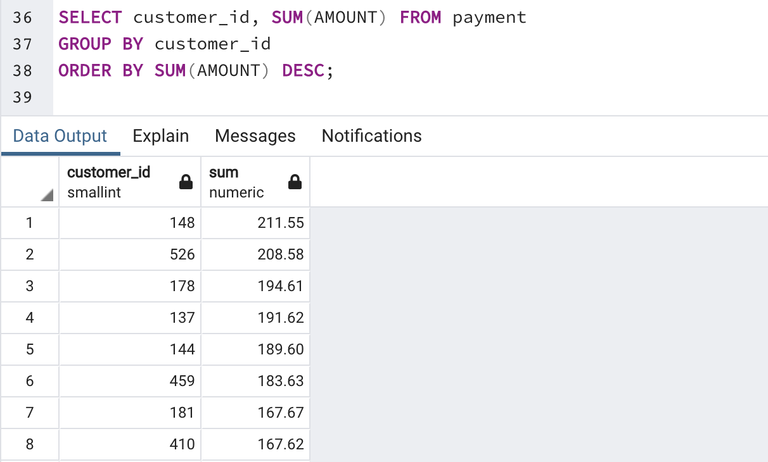

1. **Which customers have not rented any movies so far.**

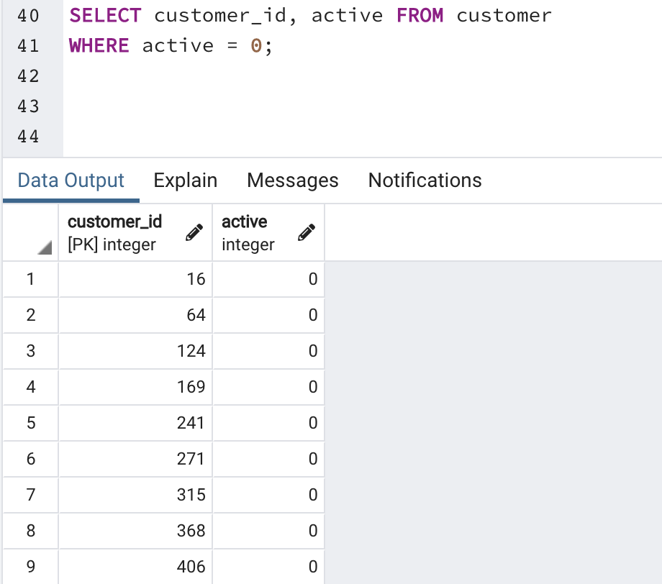

1. **How many payment transactions were greater than $5.00?**

Answer: 3618.

